EXP NO 11 Implement an application that writes data to the SD card

AIM:
To develop an Android application using Android Studio that allows users to enter data and store it in the device’s SD card (external storage).

ALGORITHM:
- Input:
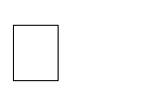
The user enters text data in the application.

The user clicks a button to save the data into the SD card.
- Steps for Implementation in Android Studio:

  - Create a New Android Project: Open Android Studio


Create a new project with an Empty Activity Choose Java or Kotlin as the programming language
  - Design the User Interface:

Add the following components in the layout:
    - EditText → to enter data
    - Button → to save data
    - TextView (optional) → to display status messages
  - Add Permissions in Manifest File:

Declare permission to write to external storage

For modern Android versions, also handle runtime permissions

  - Handle Runtime Permissions: Check if permission is granted


If not, request permission from the user at runtime Proceed only after permission is granted

  - Check External Storage Availability: Ensure that:
    - SD card is available
    - SD card is writable
  - Create File in SD Card:

Define a file name (e.g., mydata.txt)


Select appropriate directory:
    - App-specific folder (recommended)
    - Or public directory




  - Write Data to SD Card: Read input from EditText Open file output stream Write the data into the file close the stream

  - Display Output to User: Show confirmation message:
    - “Data saved successfully”
    - Or error message if something fails

  - Handle Exceptions: Manage:
    - IOException
    - Permission denial
    - Storage unavailability
- Testing the Application:


Run the app on a real device/emulator Enter sample text

Click Save button

Verify file using file manager in external storage
- Observations:


Data is stored successfully in the SD card Runtime permission handling is essential

External storage path must be handled carefully in newer Android versions

OUTPUT:


User enters text → Clicks Save Message displayed:
Data saved successfully to SD card

File mydata.txt created in external storage containing user input

CODE:
<!DOCTYPE html>
<html lang="en">
<head>
<meta charset="UTF-8">
<meta name="viewport" content="width=device-width, initial-scale=1.0">
<title>Write Data to File</title>

<style>

body{
font-family: Arial;
background-color: #f2f2f2;
}

.container{
width: 400px;
margin: auto;
margin-top: 100px;
background: white;
padding: 30px;
text-align: center;
border-radius: 10px;
box-shadow: 0px 0px 10px gray;
}

textarea{
width: 100%;
height: 150px;
padding: 10px;
font-size: 16px;
}

button{
margin-top: 20px;
padding: 10px 20px;
background-color: green;
color: white;
border: none;
cursor: pointer;
font-size: 16px;
}

button:hover{
background-color: darkgreen;
}

</style>
</head>

<body>

<div class="container">

<h2>Write Data to File</h2>

<textarea id="data"
placeholder="Enter your data here"></textarea>

<br>

<button onclick="saveFile()">
Save to File
</button>

</div>

<script>

function saveFile(){

// Get textarea data
let text =
document.getElementById("data").value;

// Create Blob
let blob = new Blob([text],
{ type: "text/plain" });

// Create download link
let link =
document.createElement("a");

link.href =
URL.createObjectURL(blob);

link.download = "sample.txt";

// Auto click download
link.click();

alert("File Saved Successfully");
}

</script>

</body>
</html>

OUTPUT:
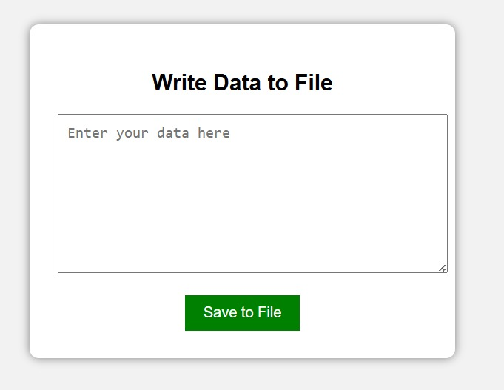

RESULT:
An Android application is successfully developed using Android Studio to write data to the SD card with proper permission handling and storage management.

